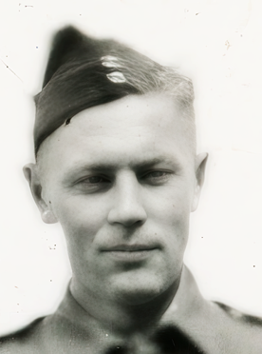

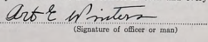

Decorations
 |  | 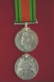 | 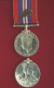 | 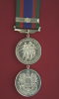 | 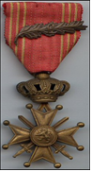
1939-1945 Star | French & Germany Star | Defence Medal | War Medal | Canadian Volunteer Service Medal Clasp | Belgium  Croix de guerre with Palm

Life Story
Arthur Emil Winters was born on August 2, 1909 in Kumilako, East Prussia, (then Germany, now Poland). When he was 15 years old, his parents were killed in an accident. After three years of local high school, he emigrated to Canada at age 17 and settled in northwestern Ontario, around Vermillion Bay. He taught himself English through conversation and with a dictionary.
Arthur initially worked as a carpenter but later bought a truck and hauled pulpwood. He was naturalized, not considered an enemy alien, although he was required to report to the Royal Canadian Mounted Police monthly and was disqualified from any coastal duties or employment. At the time of enlistment he was living in his own home, one that he built near Waldhof. He enlisted for active service in Fort William, Ontario on February 25, 1943 after a month of service in the Militia. By May 1943 he had completed his advanced training in Camp Chilliwack and arrived in England in August. He spent nearly a year in the Engineer Reinforcement Unit whre he qualified as Waterman Group ‘C’. In March 1944, Arthur was posted to the 11th Field Company and on September 9 he was promoted to Lance Corporal.
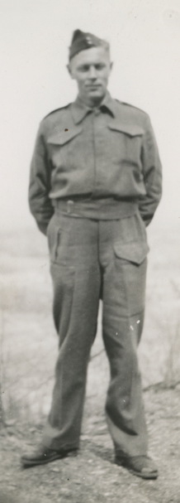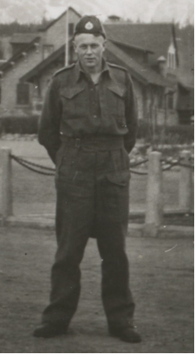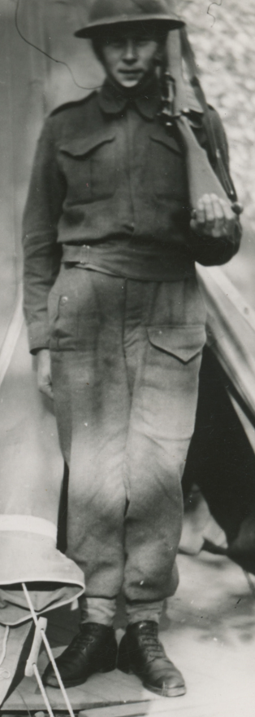

The 11th Field Company arrived in France on July 9, 1944 as part of the 2nd Canadian Division Engineers. They participated fully in all operations during the Battle of Normandy and the advance across the Seine, through the Channel Ports and into Belgium, clearing routes and building bridges. The Division was then moved north of Antwerp in preparation for the Battle of the Scheldt. While the battle officially began on October 2, 1944 when the 2nd Canadian Division crossed the Antwerp-Turnhout Canal to clear the Beveland approaches, for the RCE, the Battle of the Scheldt started before that date.
In a dull, cool and rainy night of September 30th, the 11th Field Company, 3rd Platoon was assigned to build an 80-foot Class 40 bridge across the Antwerp-Turnhout canal at Molenheiken/Klein-Veerle, west of Sint-Lenaart (locally known as Bridge 10). It became a costly task.
At 2115: the work commenced. Heavy shelling and mortars started at 2300.
At 0030, October 1st: a direct hit on the bank seat party caused six casualties. Spr Bennet was slightly wounded. Sapper Dionne and Sapper Robert Milne were killed immediately. LCpl Winters, Sappers Bell and Lowe were seriously wounded and on route to 9 Canadian Field Dressing Station (FDS) near Antwerp.
At 0430: work was suspended due to enemy shelling.
At 0700: 3 Platoon was withdrawn to the assembly area.
At 0900: 3 Platoon was relieved by 2 Platoon.
At 1600: 2 Platoon commenced work at bridge. LT Bowman returned from 9FDS and reported that Sprs Lowe and Bell died. LCPL Winters died in the ambulance.
At 2145: Bridge was completed and named Keefler Bridge (Brigadier General Keefler, Commander 2nd Canadian Division)
At October 2nd 3 PL was standing by to build the bridge at Lochtenberg. Once the work commenced three more Engineers were killed (buried at Schoonselhof Cemetery)
At October 3rd 0300: the bridge was shelled and work was suspended.
At 0815: work commenced. At 0900 the Lochtenberg bridge was completed and named Winters bridge honouring Arthur.
October 4th : A sign was attached to the bridge by Lt Bowman.
Lance Corporal Arthur Emil Winters was seriously wounded in the shelling. He died in the ambulance. He was first buried at the Roman Catholic Cemetery in Westmalle and later reburied in the Bergen-Op-Zoom Canadian War Cemetery in The Netherlands (plot 09A12). He was 35 years of age.

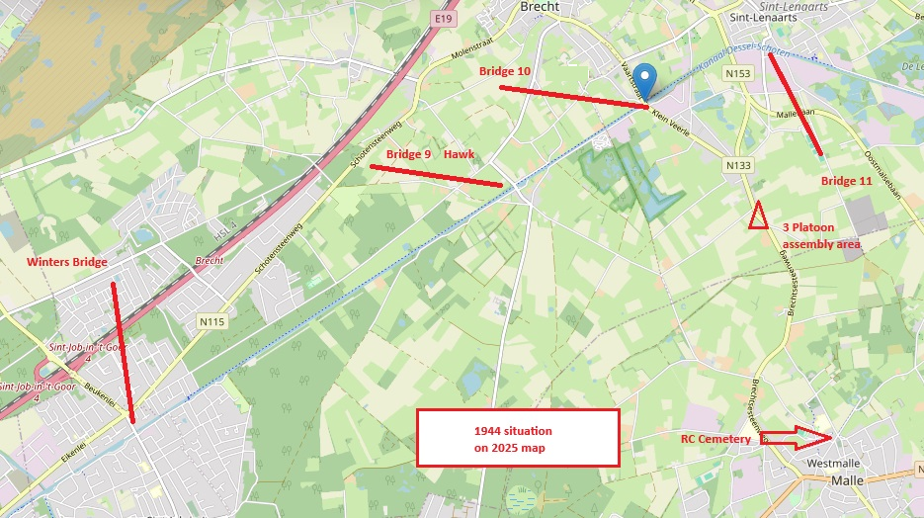

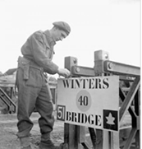

Lt W.A. Bowman attaching the sign on Winters Bridge
October 4, 1944
In 1948, the Belgium Government awarded the Croix de Guerre 1940 avec Palme to Sapper Arthur Winters in recognition of his outstanding contribution to the liberation of Belgium. The medal was presented by the Belgian Embassy to Mrs. Natalie Matteoschat (nee Mantey), friend and prospective wife who was living in Vermillion Bay, Ontario at the time.
In Arthur’s Soldier Service and Pay Book various pictures were found. It is likely that these pictures, like the ones below, are from Natalie (1902-1987) and her 3 children. In the estates document she was listed as the sole heir. Pastor Roth in Dryden stated that: “ she was not to be classified as a common law wife. Yet, the public was convinced of their complete intention of marriage as soon as more stable conditions permitted”.
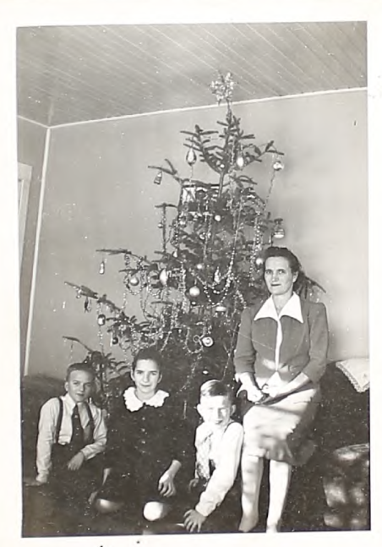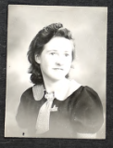
Natalie Mantey was married before WW2 to Mack Franz and remarried to Erich Matteoschot in 1946.
Mrs Franz received various documentation and items concerning Arthur’s death such as the Memorial Bar and the letter from Lt Bowman (Arthur’s Platoon Commander).

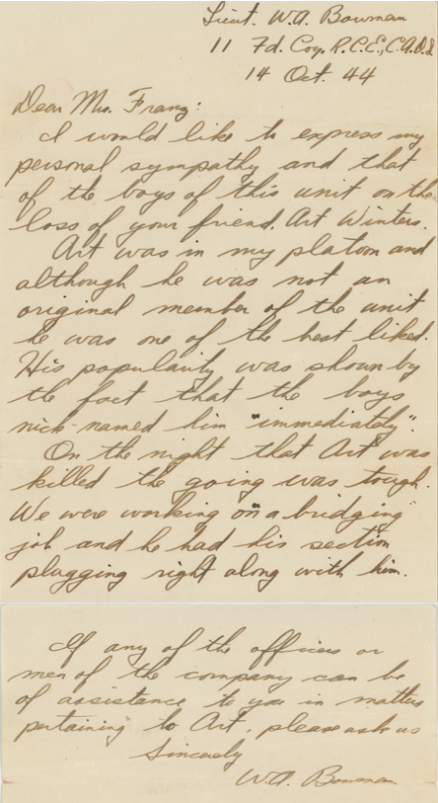
Dear Mrs Franz:

I would like to express my personal sympathy and that of the boys of this unit on the loss of your friend, Art Winters.

Art was in my platoon and although he was not an original member of the unit he was one of the best liked. His popularity was shown by the fact that the boys nick-named him immediately.

On the night that Art was killed the going was tough. We were working on a bridging job and he had his section plugging right along with him.

If any of the officers or men of the company can be of assistance to you in matters pertaining to Art, please ask us.

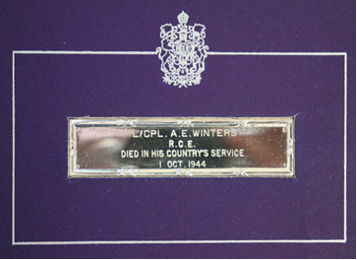
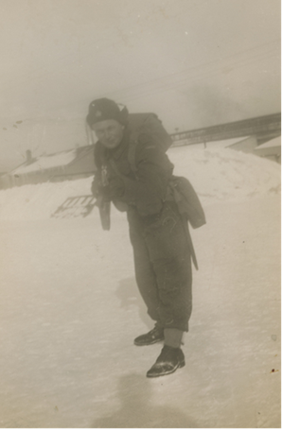

The above document and pictures from Arthur were kept at the local inn which was most likely the boarding house that Natalie Franz ran. When, years later, the inn closed, LCpl Winter’s memorabilia were delivered to the Lake of the Woods museum in Kenora. (Courtesy by Marcus Jeffrey)

